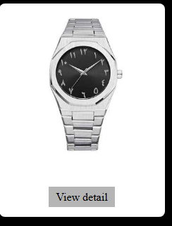

**Product Name:** Silver Stainless Steel Arabic Dial Wristwatch

**Description:**  
Elevate your style with this sleek and modern wristwatch featuring a minimalist black dial adorned with Arabic numerals. Housed in a polished stainless steel case and paired with a matching bracelet, this timepiece is perfect for everyday elegance or formal wear. The analog display ensures classic timekeeping, while the secure clasp provides a comfortable and reliable fit.

* **Case Material:** Stainless Steel
* **Band Material:** Stainless Steel
* **Dial Color:** Black
* **Numerals:** Arabic
* **Movement:** Quartz
* **Water Resistance:** Splash resistant
* **Gender:** Unisex

**Price:** $79.99